**Australian Islamic College 2019**

**ATAR Chemistry Units 3 and 4**

**Task 12 (Weighting: 3%)**

**Polymers and Chemical Synthesis Test**

Test Time: 45 minutes

Please do not turn this page until instructed to do so.

|  |  |
| --- | --- |
| **First Name** | **Surname** |
|  |  |

|  |
| --- |
| **Teacher** |
|  |

|  |  |
| --- | --- |
| **Mark / 43** | **Percentage** |
|  |  |

Equipment allowed: Pens, pencils, erasers, whiteout, correction tape, rulers and non-programmable calculators permitted by the Schools Curriculum and Standards Authority.

**Special conditions**:

2 marks will be deducted for failing to write your full name on this test paper.

**Teacher help**: Your teacher can only help you during your test in one situation.

If you believe there is a mistake in a question show your teacher and your teacher will tell you if there is a mistake in the question and if appropriate, how to fix that mistake.

**Spelling of Science words** must be correct. Science words with more than one letter wrong (wrong letter and/or wrong place) will be marked wrong.

Unless stated otherwise, **equations** must be written balanced and with correct state symbols or they will be marked wrong.

Questions must be answered in this booklet.

Total marks: 43

**PART ONE: MULTIPLE CHOICE QUESTIONS (9 MARKS)**

**Circle the most correct answer.**

1. Which of the following is the best definition of a condensation polymer?
   1. It is a long, saturated molecule formed when two unsaturated molecules combine in a chain reaction.
   2. It is a polymer that is formed when two gaseous molecules react to form a substance that is liquid at room temperature.
   3. It is a long chain molecule formed in a reaction that produces water as one of the products.
   4. It is a polymer containing non-polar and polar sections, which allow it to act as a surfactant.
2. Which of the following is not used as a raw material in the manufacture of sulfuric acid?
   1. Water
   2. Oxygen
   3. Sulfur
   4. Iron
3. The “key” step in the Contact Process is:

2SO2(g) + O2(g) 2SO3(g); ∆H is negative



Which of the following conditions achieves the highest reaction yield?

* 1. Low temperature; high pressure.
  2. High temperature; pressure higher than atmospheric pressure.
  3. Low temperature; pressure lower than atmospheric pressure
  4. High temperature; low pressure.

1. When ethene reacts with steam in the presence of a catalyst, what is the molecular formula of the product formed?
   1. C2H6
   2. C2H5O
   3. C2H6O
   4. C2H4O2
2. How many different tripeptides can be formed using only the amino acids glycine (Gly) and alanine (Ala)?
   1. 2
   2. 3
   3. 6
   4. 8
3. Which one of the following would be made from the polymerisation of 1,3-dichlorobut-2-ene?

C

C

(a)

CH

CH2

CH2

C

H

n

CH2C

CH

CH3

CC

n

(b)

(c)

C

C

CH2

CH2

CH2

CH

n

(d)

CH3

CC

CH3

CC

n

1. A newly developed drug, X, is prepared in a difficult three-step reaction sequence. The percentage yield for each step of the sequence is shown below.

A → B → C → drug X

% yield 18 % 70% 10%

Which of the following is closest to the overall percentage yield for the conversion of A to drug X?

* 1. 1
  2. 10
  3. 33
  4. 98

1. The diagram below represents the making of soap.

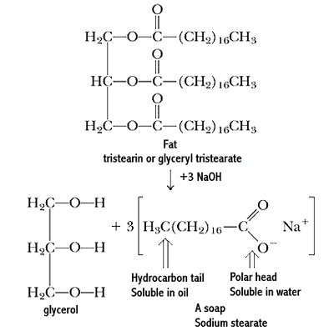

Which one of the following options is correct?

|  |  |  |  |
| --- | --- | --- | --- |
|  | Product 1 | Product 2 | Chemical process |
| (a) | glycerol | sodium stearate | esterification |
| (b) | glycerol | stearic acid | hydrolysis |
| (c) | 1,2,3-propanetriol | sodium stearate | saponification |
| (d) | 1,2,3-propanetriol | sodium glycerate | ionisation |

1. Large quantities of hydrogen gas are produced industrially by the steam reforming of natural gas. The equation for this reaction is as follows.

CH4(g) + H2O(g) ⇌ CO(g) + 3H2(g); Δ*H* = +206 kJ mol-1

Which of the following changes will increase the amount of H2(g) at equilibrium?

I increasing temperature

II increasing the pressure

III adding a catalyst

* 1. I only
  2. II only
  3. I and II only
  4. I, II and III

**END OF MULTIPLE CHOICE SECTION**

**PART TWO: SHORT ANSWER QUESTIONS (34 marks)**

Answer all questions. Write your answers in the spaces provided.

1. The structure of a polymer is shown below:



* 1. What type of reaction is used to synthesis this polymer?

(1 mark)

* 1. In the same style as in part (a) above, draw the structure of the polymer formed from the combination of the two monomers below:

(2 marks)





* 1. Draw the structure of the molecule 2-methylbut-2-ene and draw the structure of the polymer formed from this monomer.

(3 marks; 1 for the monomer and 2 for the polymer)

1. The contact process is part of the production of sulfuric acid. Sulfur trioxide is produced by the reaction shown here. This can then be converted into sulfuric acid in the next step of the process.

2SO2(g) + O2(g) ⮀ 2SO3(g) + HEAT

A chemical engineer monitored the reaction, with the concentrations of oxygen and sulfur trioxide being plotted over a period of time. The results are shown here:

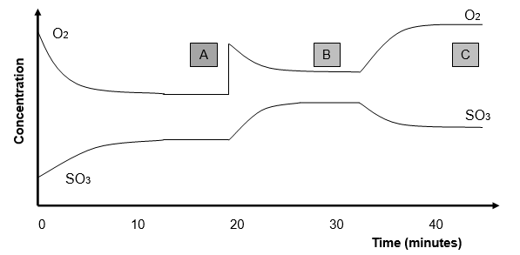

* 1. Write the equation for the equilibrium constant (K) for this reaction.

(1 mark)

* 1. More oxygen is added to the system after 20 minutes. Explain the shape of the graph over the next 5 minutes.

(2 marks)

* 1. The temperature of the system was increased after 33 minutes. At what point would the equilibrium constant be the lowest; A, B or C?

(1 mark)

* 1. Justify your answer to part (c) of this question.

(2 marks)

1. The following flow chart represents the Haber process.

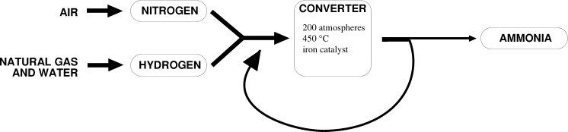

* 1. Give ONE example of an industrial use of ammonia.

(1 mark)

* 1. For the manufacturer, the ultimate purpose of conducting the Haber process is to make a financial profit. State two ways that the use of a catalyst can increase profits during the industrial synthesis of a chemical.

(2 marks)

* 1. Use “Collision theory” to explain how ammonia forms and why an increase in temperature increases the reaction rate.

(3 marks)

* 1. Given that an increase in temperature increases the reaction rate in the Haber process, explain in terms of Le Chatelier’s Principle why an even greater reaction temperature is not used in an industrial setting.

(2 marks)

* 1. How is the ammonia removed from the unreacted gases? Include in your answer an explanation in terms of intermolecular forces why this separation method can be used.

(2 marks)

1. One of the most commonly recycled plastics is PET (polyethylene terephthalate). It is a copolymer that is used to make drink bottles as it is strong and not brittle.

The two different monomers in PET are called polyethylene glycol and terephthalic acid (these are non-IUPAC names).

* 1. Draw the two monomers that combine to make PET.

(2 marks)

* 1. Draw the polymer PET.

(1 mark)

* 1. What type of polymerisation process is used to produce PET?

(1 mark)

* 1. Based solely on the types of intermolecular forces present, would you expect the intermolecular forces to be stronger in PET or in polyethylene? Include in your answer the names of the predominant intermolecular force present in each polymer.

(3 marks)

1. The following equilibrium reaction is a step in the production of nickel metal.

Ni(NH3)42+(aq) + H2(g) Ni(s) + 2NH4+(aq) + 2NH3(g); ∆H = -ve



List 6 ways that the yield of this reaction could be increased.

(3 marks; ½ each)

1. Ethanol is produced as a fuel. When it is combusted carbon dioxide, a global warming gas, is produced. Explain why the production of ethanol by the hydration of ethene contributes to global warming whereas the production of the same substance by the fermentation of corn does not contribute to global warming.

(2 marks)

**END OF TEST**

**Blank Page For Student Use. This Page Will Not Be Marked.**